int pirPin = 2;
int ledPin = 13;

void setup() {
pinMode(pirPin, INPUT);
pinMode(ledPin, OUTPUT);
Serial.begin(9600);
}

void loop() {
int motion = digitalRead(pirPin);

if (motion == HIGH) {
Serial.println("Motion Detected!");
digitalWrite(ledPin, HIGH);
} else {
Serial.println("No Motion");
digitalWrite(ledPin, LOW);
}

delay(1000);
}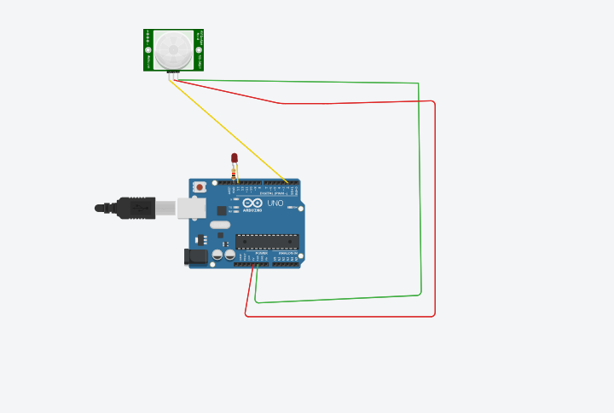
https://www.tinkercad.com/things/lg98pCoeevC-pir-sensor?sharecode=flc_7_jI0LjbnTWFkOJ66WukWvnJgZvgtaoHWEGU4Ao

